Distribution storage flow

- Authoring tier - local disk / Azure Files (IStorageService / LocalStorageService)
- Distribution tier - Azure Blob / Local dist folder (IBlobDistributionService)

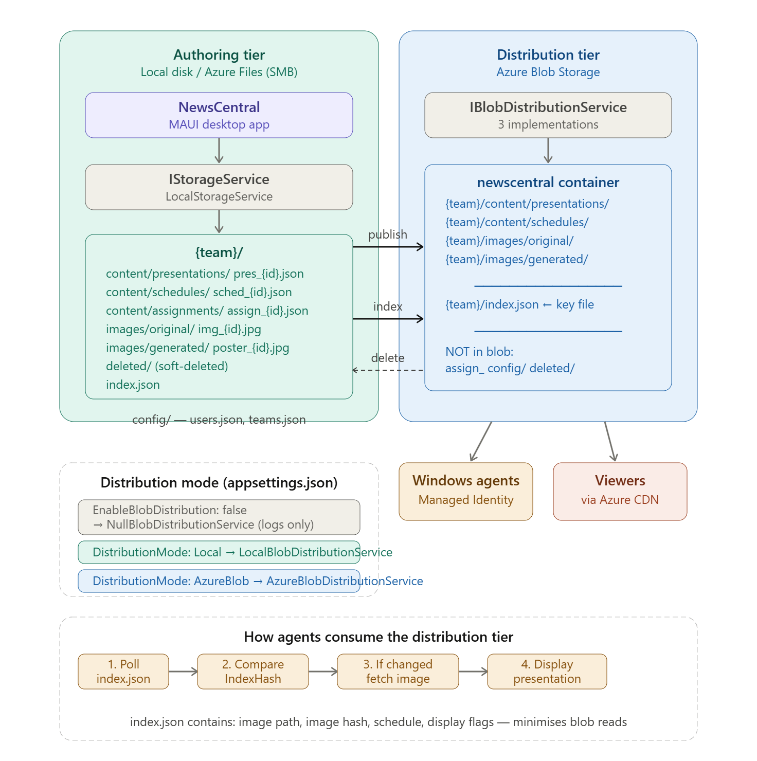

Here is how the two tiers work together:
Authoring tier is where NewsCentral operates day-to-day — create, edit, approve, soft-delete. LocalStorageService handles all reads and writes against DataPath. This tier is the source of truth. assign_ files, config/, and deleted/ never leave it.
Distribution tier receives content only through three specific service calls, each non-fatal if it fails:
- PublishingService — on publish, pushes presentation JSON, schedule JSON, and image stream to blob under the target team prefix
- IndexGenerationService.SaveIndexFileAsync — the single chokepoint for index.json; called automatically at the end of every publish and delete, pushing the updated index to blob immediately
- PresentationService.DeletePresentationAsync — on cascade delete, removes the published blobs for each affected assignment, then triggers an index regeneration
What stays out of blob deliberately: assignment files (internal tracking only — agents don't need them), config/ (users and teams — private), and deleted/ (soft-delete archive — internal).
The index.json is the key file. It is a pre-computed summary containing image paths, image hashes, schedule dates, and display flags for every published assignment in a team. Agents read this single file to determine whether anything changed (IndexHash comparison), and only then fetch the actual image. This keeps blob request counts low regardless of viewer volume.
The three modes map directly to the current development progression — false (logs only, current state), Local (files appear in NewsCentralDist\, ready to test), AzureBlob (production). Switching is a single line in appsettings.json:
{
"DataPath": "C:\\Download\\NewsCentral",
"Initialization": {
"DefaultAdminUsername": "admin",
"DefaultAdminPassword": "admin",
"DefaultTeamName": "My Team",
"DefaultTeamFolderName": "MY_TEAM",
"DefaultTeamDescription": "Default team"
},
"LockExpirationMinutes": 15,
"Authentication": {
"EnableAutoLogin": false,
"UseMockUPN": true,
"MockUPN": "petr.prachar@company.com"
},
"AI": {
"ClaudeApiKey": "",
"ClaudeApiUrl": "https://api.anthropic.com/v1/messages",
"OpenAIApiKey": "",
"OpenAIApiUrl": "https://api.openai.com/v1/chat/completions"
},
"Storage": {
"EnableBlobDistribution": false,
"DistributionMode": "Local",
"LocalDistributionPath": "C:\\Download\\NewsCentralDist",
"AzureBlobConnectionString": "",
"AzureBlobContainerName": "newscentral"
}
}

All three states:
"Storage": {
"EnableBlobDistribution": false, // ← Mode 1: Null — logs only, nothing written
"DistributionMode": "Local", // ignored when EnableBlobDistribution = false
"LocalDistributionPath": "C:\\Download\\NewsCentralDist",
"AzureBlobConnectionString": "",
"AzureBlobContainerName": "newscentral"
}
"EnableBlobDistribution": true,
"DistributionMode": "Local" // ← Mode 2: files written to LocalDistributionPath
"EnableBlobDistribution": true,
"DistributionMode": "AzureBlob" // ← Mode 3: files pushed to AzureBlobConnectionString
Two things worth noting:
DistributionMode is only read when EnableBlobDistribution is true — so you can leave it set to "Local" while EnableBlobDistribution is false without any side effect. When you're ready to test, flipping EnableBlobDistribution to true is the only change needed to activate whichever mode is already set.
LocalDistributionPath and AzureBlobConnectionString are independent — both can be populated at the same time. Only the active mode uses its corresponding setting, so you can have the local path configured for testing and the connection string ready for production without them interfering with each other.

